# Where to Open the Next Restaurant in Toronto?

Contents

Where to Open the Next Restaurant in Toronto? 1

Introduction/Business Problem 1

Data 1

Methodology 2

Results 3

Discussion 4

Conclusion 4

## Introduction/Business Problem

A customer is planning to open a new restaurant in Toronto. However, he is not sure where exactly he should open the restaurant. He would prefer to open the restaurant at a **lively** place and also with a lot of **diversities**.

## Data

**1. Neighborhoods in Toronto from** <https://en.wikipedia.org/wiki/List_of_postal_codes_of_Canada:_M>

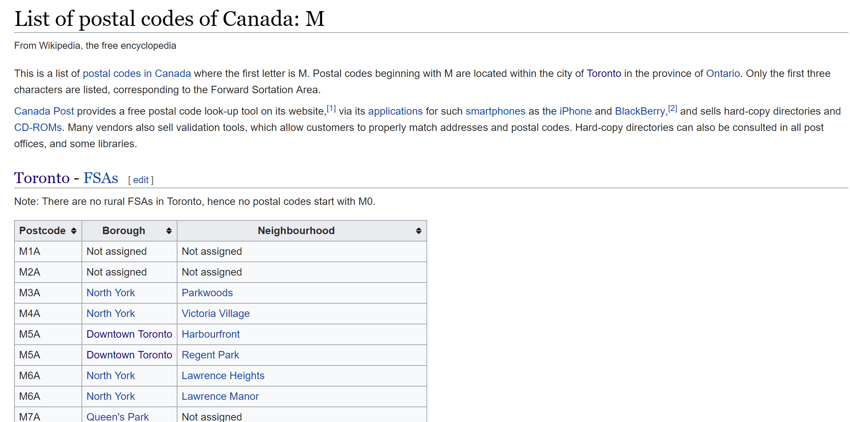

**2. Geolocation data from** [**https://cocl.us/Geospatial_data**](https://cocl.us/Geospatial_data%20-O%20Geospatial_data.csv)

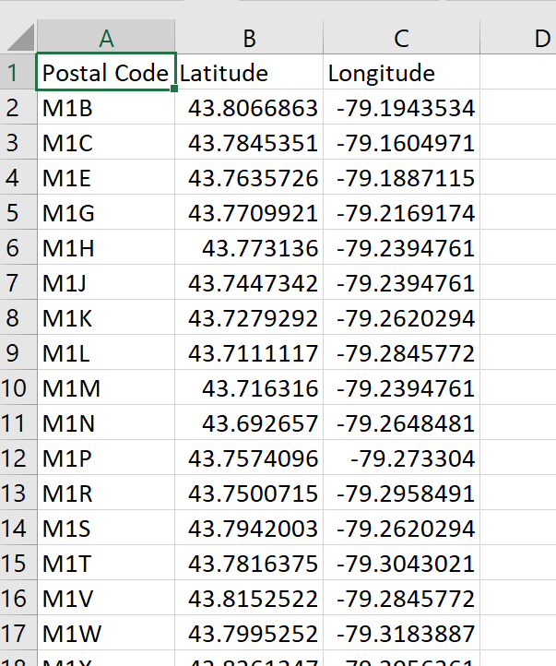

3.Venues Data from Foursquare

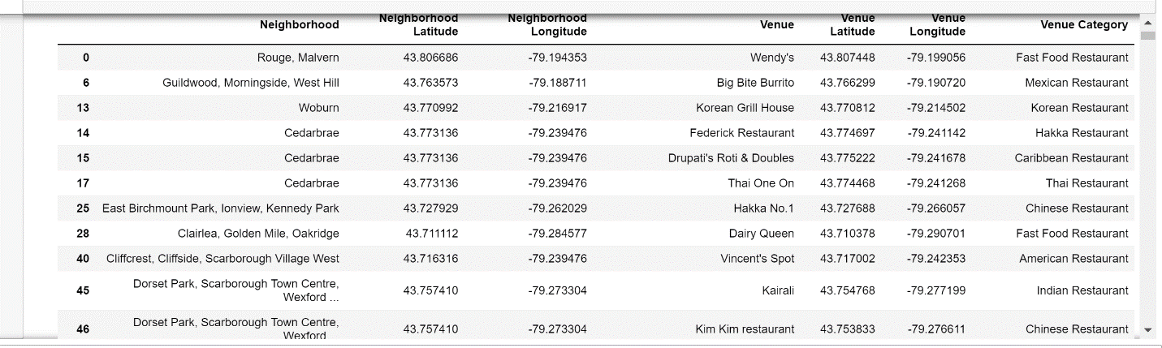

## Methodology

I'm going to scrape the location data of the neighborhoods in Toronto from https://en.wikipedia.org/wiki/List_of_postal_codes_of_Canada:_M

Then I combine the above info with Geolocation data from [https://cocl.us/Geospatial_data](https://cocl.us/Geospatial_data%20-O%20Geospatial_data.csv). Make a map using these info to have a overview of the neighborhood distribution.

Then I'm going to use the Foursquare location data to get the venues information in all the neighborhoods.

Since the problem is restaurant related, I’m going to filter other venues info except for restaurants.

Then I'm going to cluster the neighborhoods according to their restaurants venues information.

Then find the location that's close to a diversity of clusters of restaurant neighborhoods.

## Results

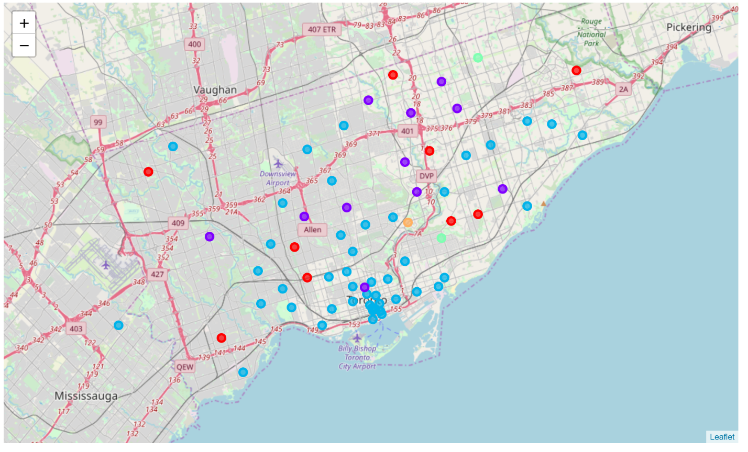

Most Diversity

Largest Density

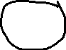

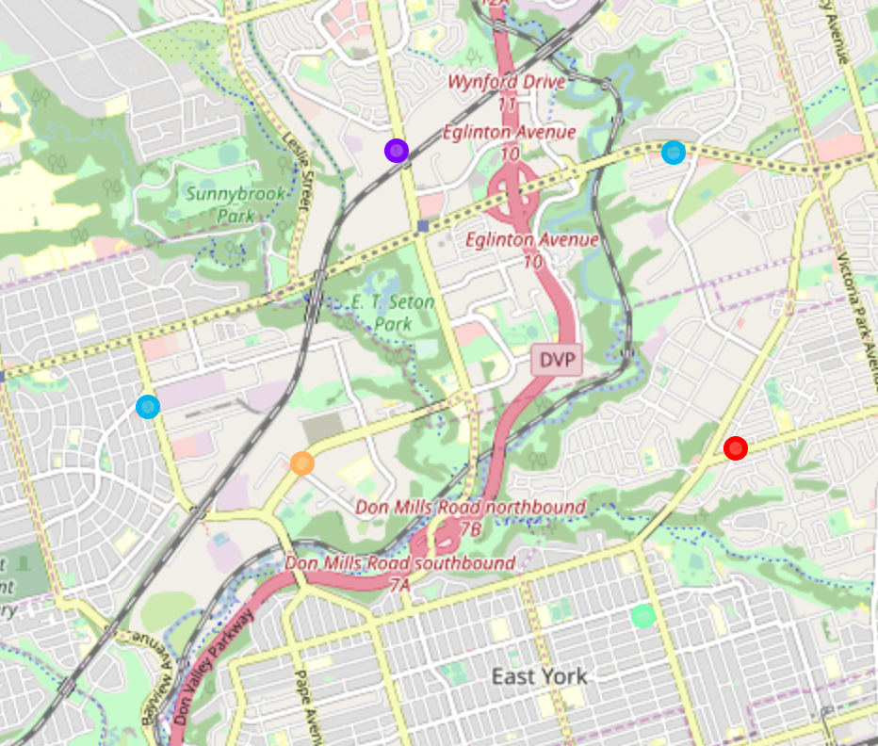

## Discussion

As we can see the largest cluster of neighborhoods with similar restraints is the blue ones. And Most of them are located in downtown Toronto. With the second largest being the purple ones scattered in the north part of Toronto. In particular, the area to the north of East York has the 5 neighborhood in 4 different clusters which could be a signal of the area with most restaurant diversity.

## Conclusion

Downtown Toronto is the most lively place in regards of number of neighborhoods with restaurants open. And if the owner want to look for a place where there's more diversity, maybe he could consider north to East York where different clusters of neighborhoods meet.